**GERALDINE YANNI MAKER MONDAY**

**FOR GRADES 4-6th ONLY**

AT 6PM

**Registration is required 724-274-9729.**

(This is a club, when you sign up for Maker Monday you are signing up for the year).

November 13 – Native Trees & Leaves

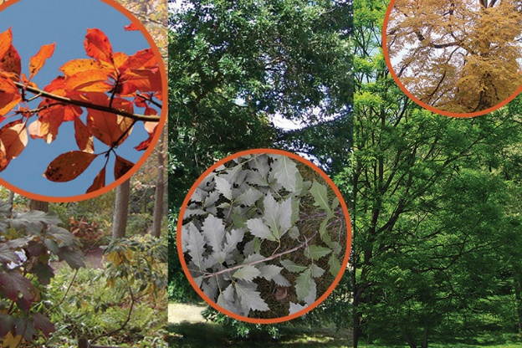

November 27 – Zip Line Racer

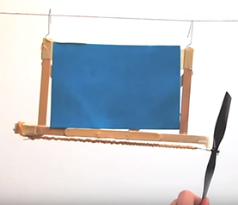

Springdale Free Public Library

331 School Street

Springdale PA 15144